**Html**

**Html:** HTML Stands for Hyper Text Markup Language. HTML code will have the file

extension as .html.It is used to write User Interface for Web Development programs.

Example code:

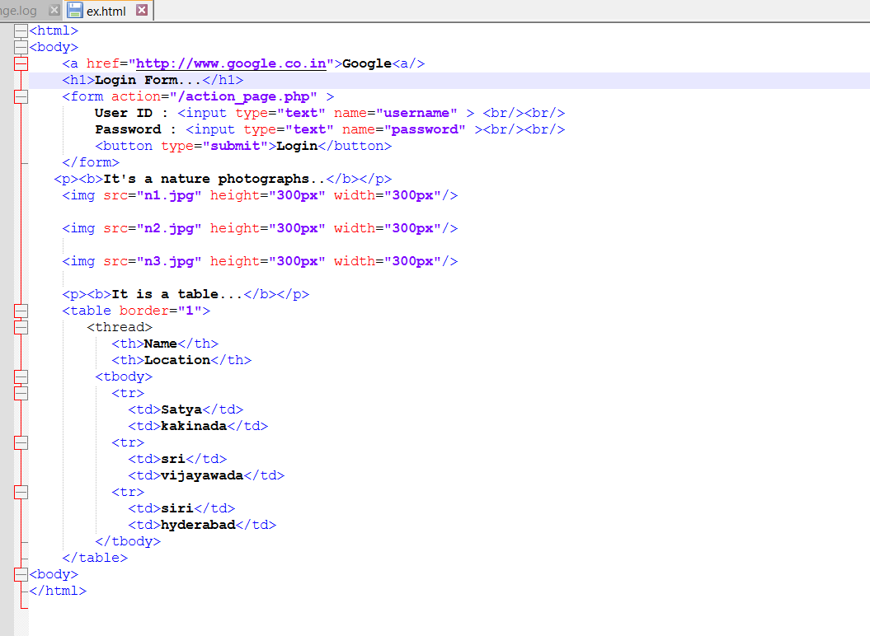

Output:

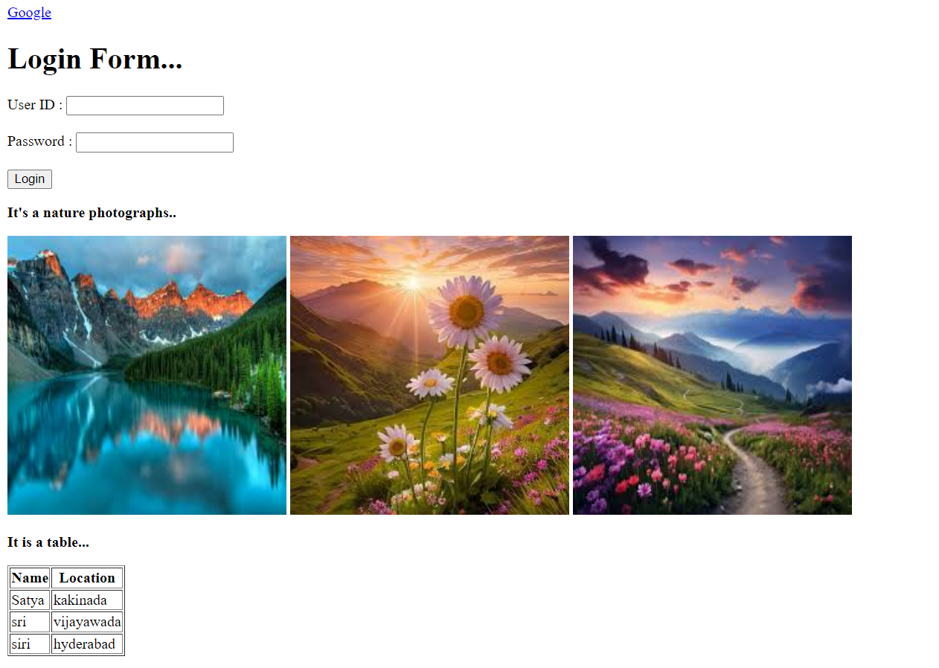

Code1:

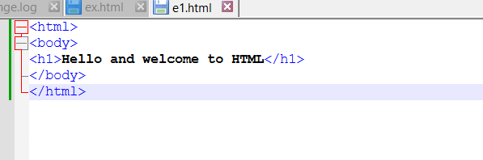

Output:

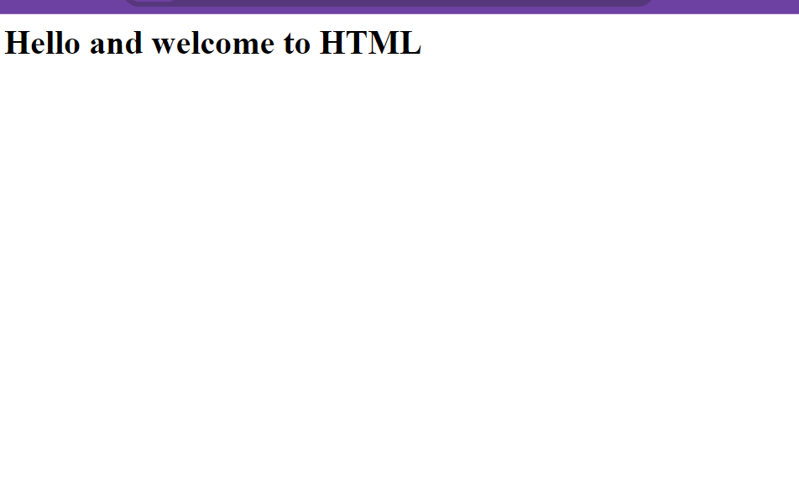

**Html elements:**

HTML documents are composed of elements, which include a start tag, content, and an end tag. The format is: <tag> Content </tag>

ex:<h1>Welcome to HTML!</h1>

In this case, <h1> is the start tag, Welcome to HTML! is the content, and </h1> is the end tag. The tags are not case-sensitive.

**Nested elements:**

HTML elements can be nested within each other, which is known as nesting.

ex: the <p> tag is used for paragraphs, and both <h1> and <p> tags can be nested inside the <body> tag, which defines the body of the HTML document.

**Code for nesting elements:**

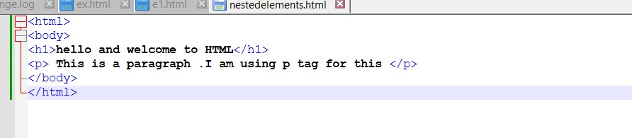

**Output:**

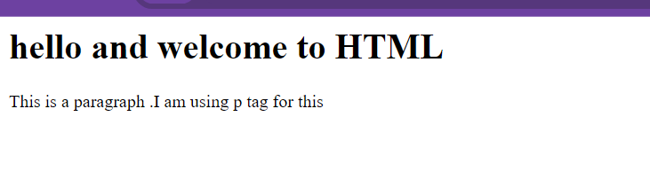

**Html attributes:**

HTML elements can have attributes that provide additional information. Attributes are specified in the start tag of the element and are always in key-value pairs, such as width="200", where width is the key and 200 is the value.  
  
HTML attributes code:

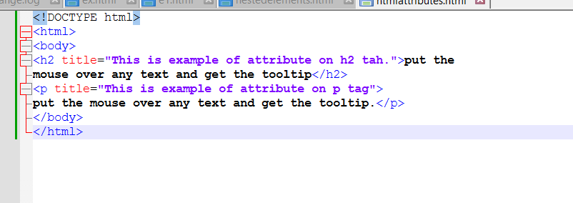

Output:

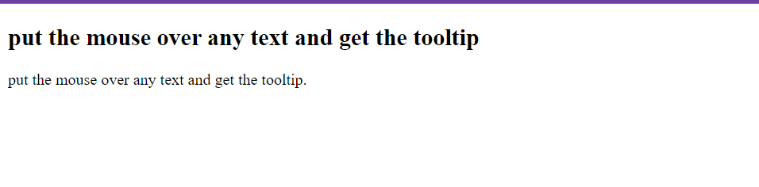

The title attribute can be used with both <h1> and <p> tags. It displays a tooltip when the user hovers over the element.

For example, <h1 title="Example of H1 tag">Header</h1> will show "Example of H1 tag" as a tooltip when hovered. Similarly, <p title="Example of P1 title">Paragraph</p> will show "Example of P1 title" when hovered.

**Html src attribute:**

The <img> element uses the src attribute to specify the image file's location and name. It doesn't have an end tag; instead, it is self-closing with />, like this:

**<img src="image.jpg"/>**

**Src attribute code:**

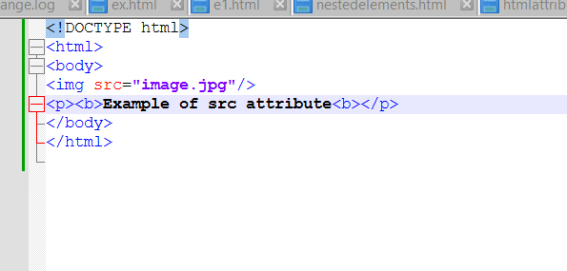

**Output:**

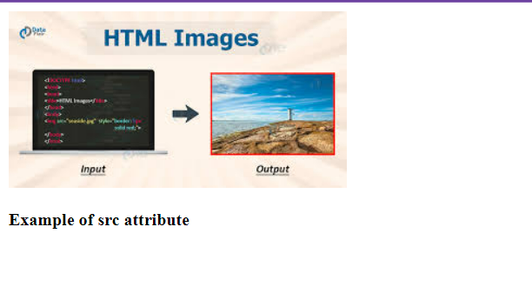

**HTML Attributes – height and width:**

In the <img> element, along with the src attribute, you can also specify height and width attributes in pixels.

Ex:<img src="image.jpg" height="300" width="300"/>

This sets the image size to 300x300 pixels. The <p> tag is used to write paragraphs.

**Html-attributewith height and width code:**

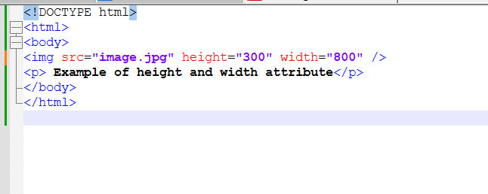

**Output:**

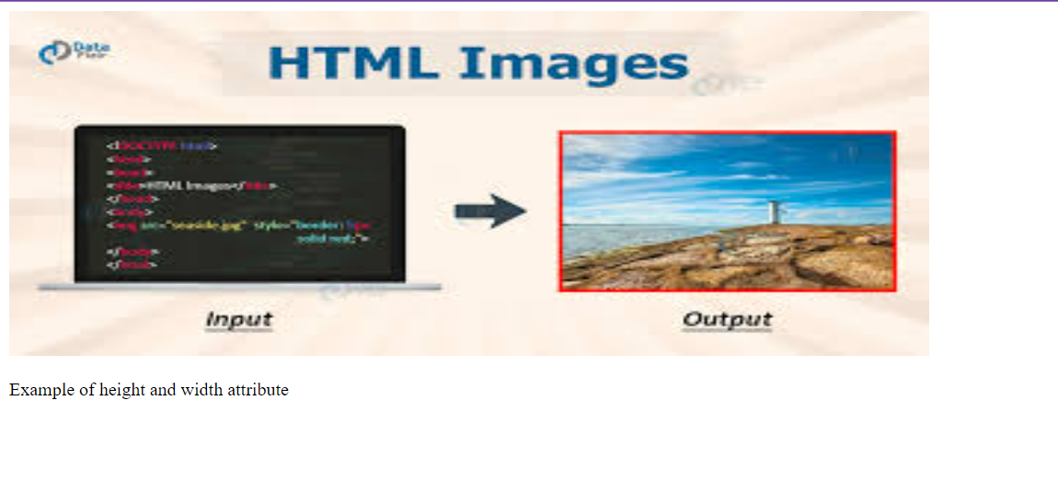

**Html alt attribute:**

The alt attribute in the <img> tag provides an alternative text message if the image cannot be displayed, such as due to a missing file or a slow internet connection. For example:

<img src="a.jpg" alt="Sorry! The image is not available"/>

Htmlalt code:

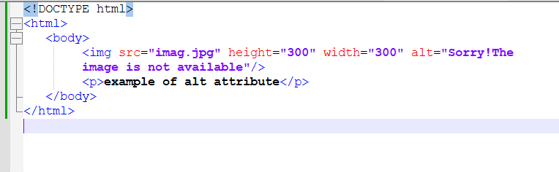

Output:

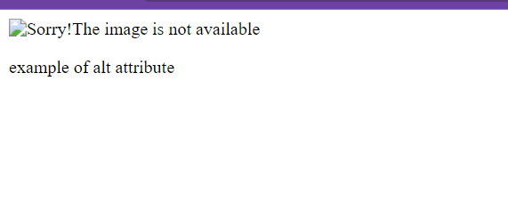

**HTML Header:**

The <head> tag contains all the header elements of an HTML document. The <title> tag sets the webpage's title, such as "My Data". Other tags that can be included in the <head> are:

* <style>: Specifies CSS styles.
* <script>: For JavaScript or jQuery scripts.
* <link>: Links to an external stylesheet.

Header code:

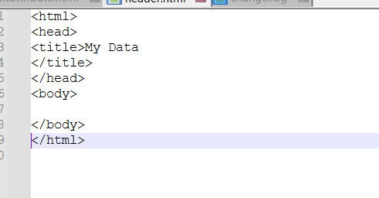

Output:

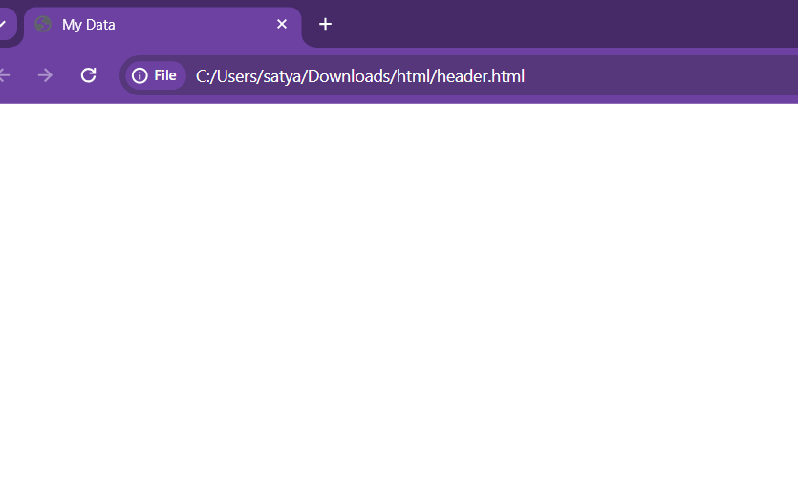

HTML provides six header tags, H1 to H6. H1 displays the largest header, and H6 displays the smallest. Each subsequent header tag (H2 to H6) displays text in progressively smaller sizes compared to the previous header tag.

Multiple headers code:

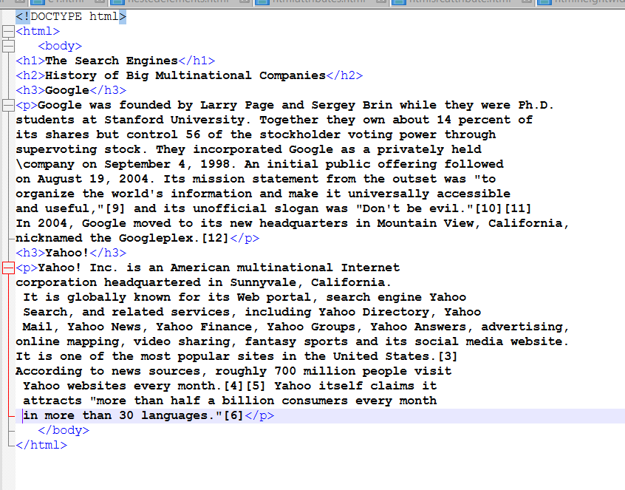

Output:

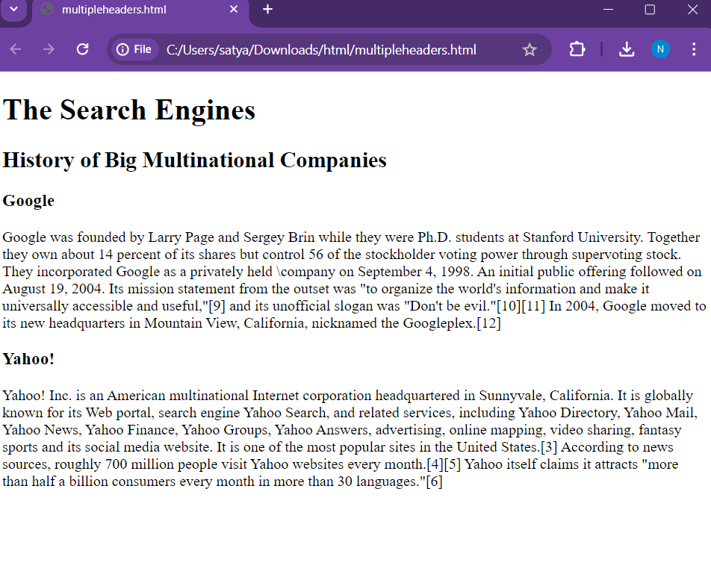

**HR tag is used to display horizontal line as show below:**

**Hrheadercode:**

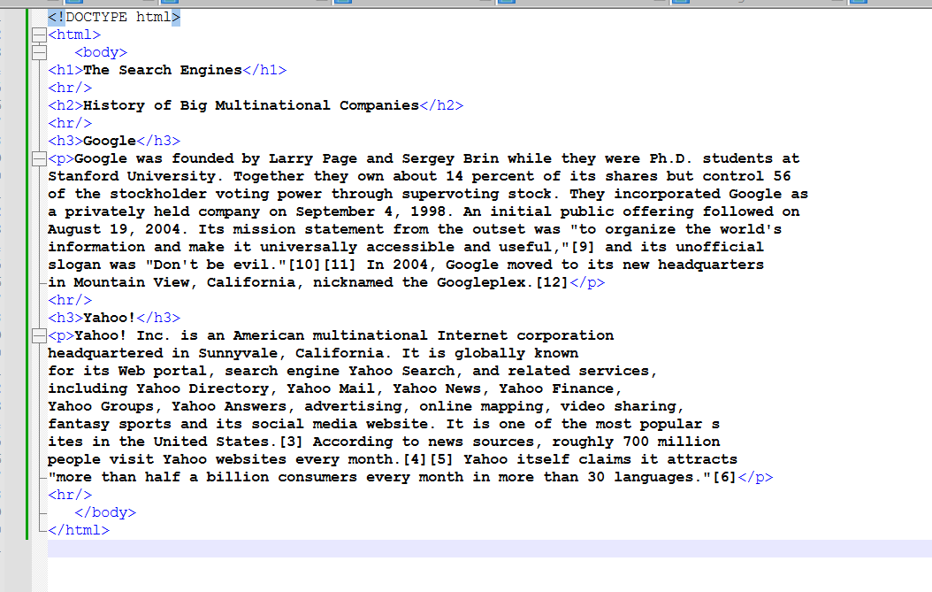

**Output:**

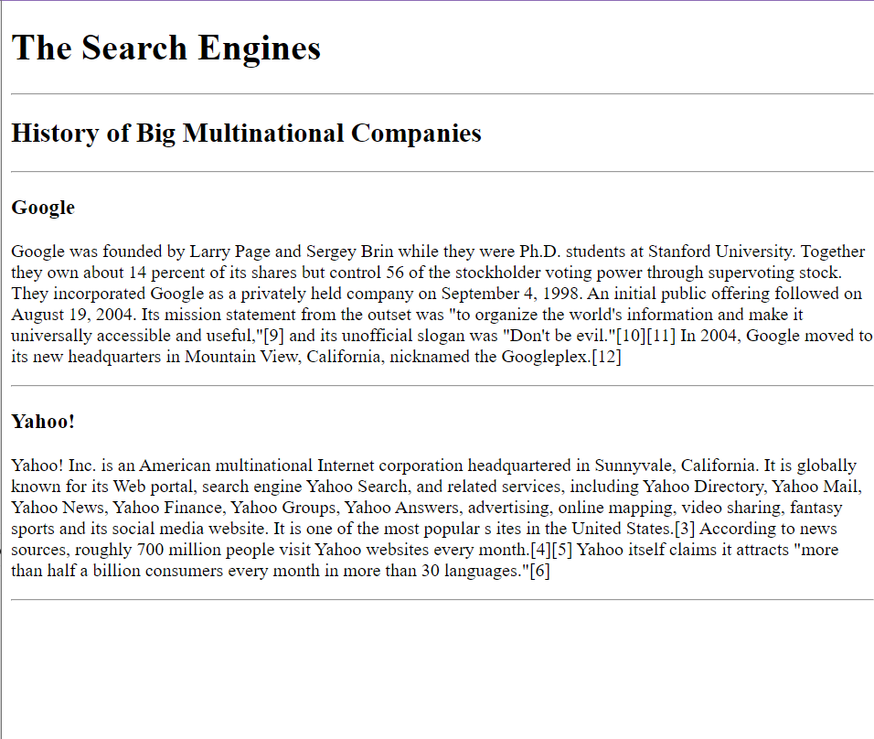

**Html paragraphs:**

The <p> tag defines paragraphs in HTML, and </p> adds a blank line after each paragraph. To create a line break, use the <br> tag.

**Paragraphs code:**

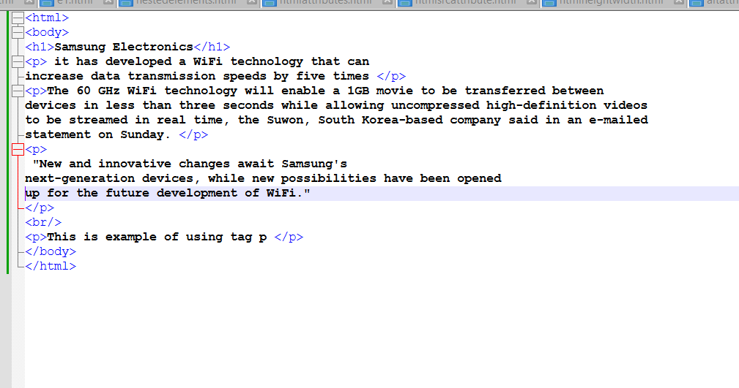

**Output:**

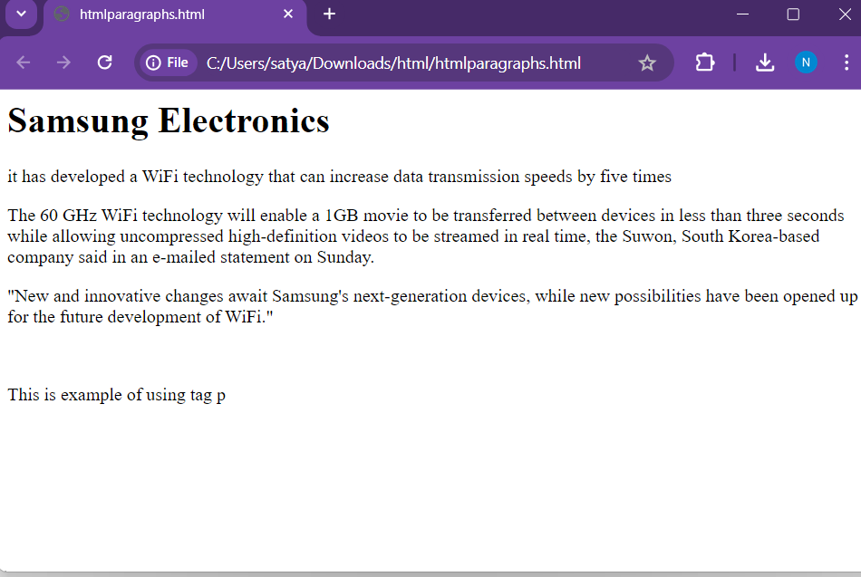

**‘**

**HTML Paragraphs with <pre> tag.:**

The <pre> tag displays pre-formatted text exactly as written in the HTML code, preserving spacing and line breaks.

**Pretag code:**

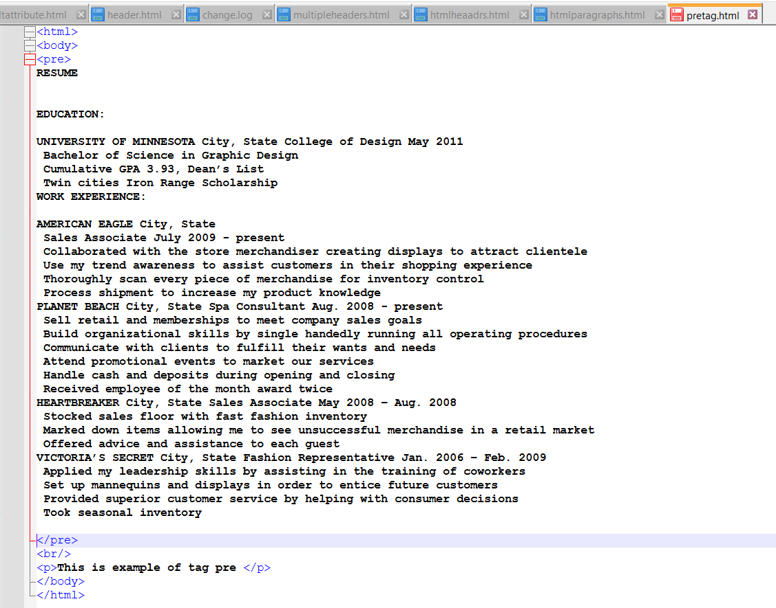

**Output:**

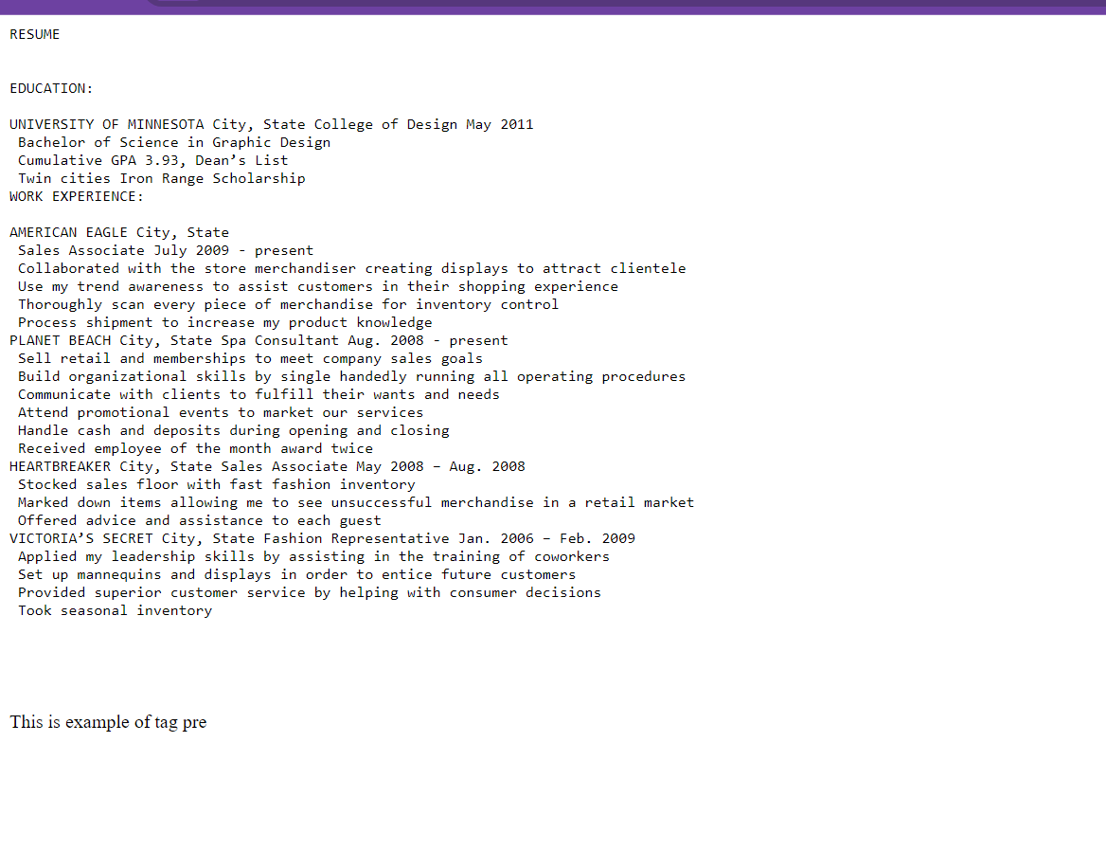

**Some of the tags which can be used for Formatting are:**

<b> - For bold.

<strong> - Emphasized bold

<i> - Italics.

<em> - Emphasized text. Displays in italics but emphasized more.

<mark> - Highlights the text like a highlighter.

<del> - Displays the text and strikes out.

<ins> - Inserted text. Displays text and underlines it as in Word doc.

<sub> - Displays text in Subscript.

<sup> - Displays text in Superscript format

**Boldtag code:**

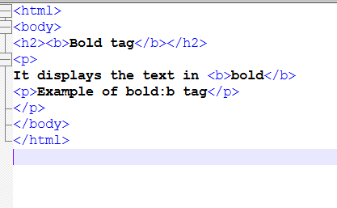

**Output:**

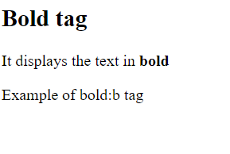

**Italic example code:**

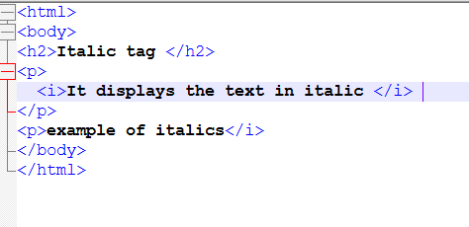

**Output:**

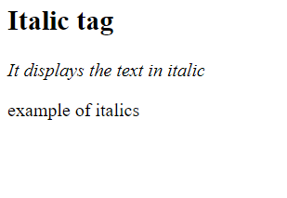

**Mark and delete code:**

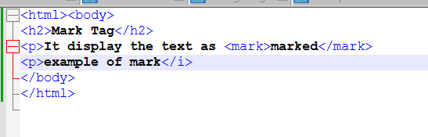

**Output:**

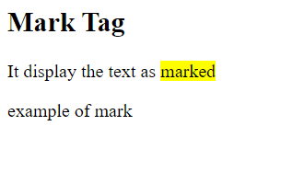

**Delete tag code:**

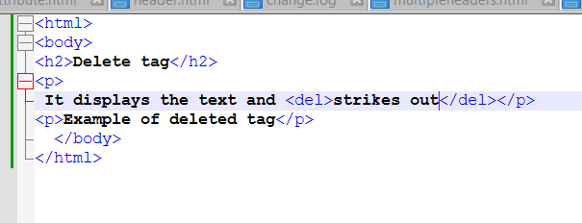

**Output:**

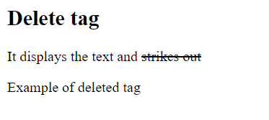

**Html links:**

HTML hyperlinks use the <a> tag. For example:

<a href="http://www.yahoo.com/html/">Yahoo</a>

"Yahoo" is the hyperlink text, and clicking it opens Yahoo's website. The href attribute can link to various file types and URLs.

Linktag code:

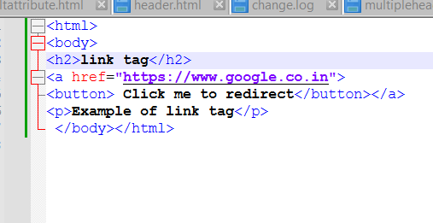

Output:

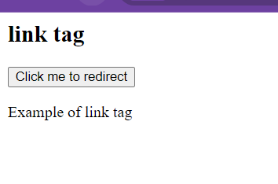

**Image hyperlinks code:**



**Output:**

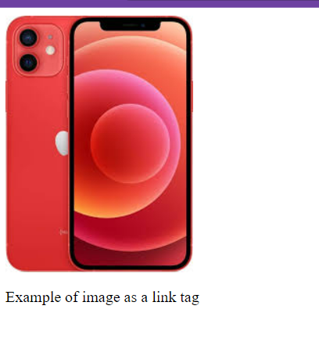

.

**Changing the colors of the hyperlinks:**

The <style> tag specifies the style of the web page. More details will be covered in CSS (Modules 3 to 5).

* link: Unvisited link.
* visited: Link after it has been clicked.
* hover: When the mouse cursor is over the element.
* active: When the hyperlink is clicked**.**

**Colors changing code:**

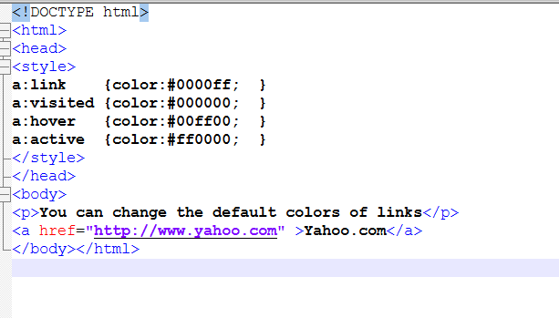

**Output:**

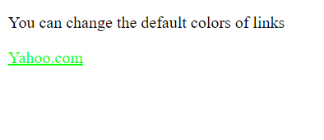

**Specifying styles for html elements code:(inline css)**

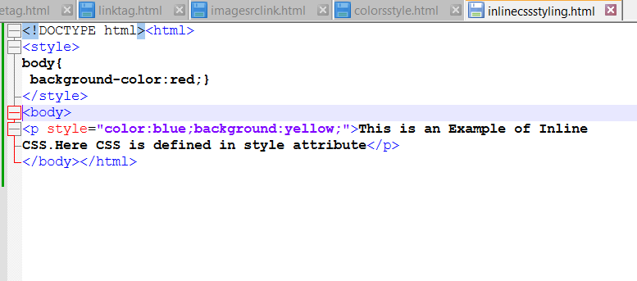

**Output”**

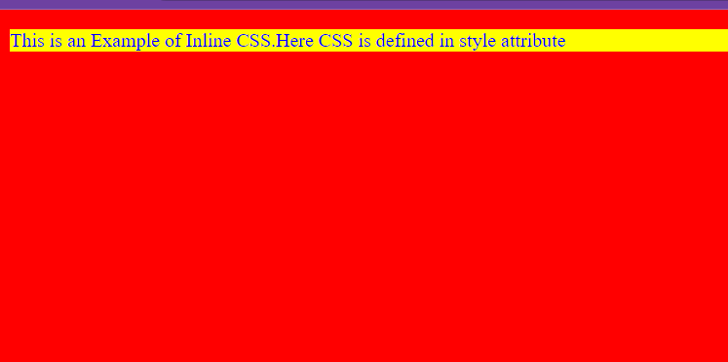

**Internalcss:**

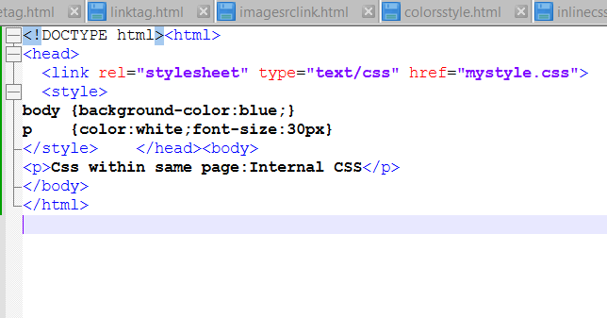

**Output:**

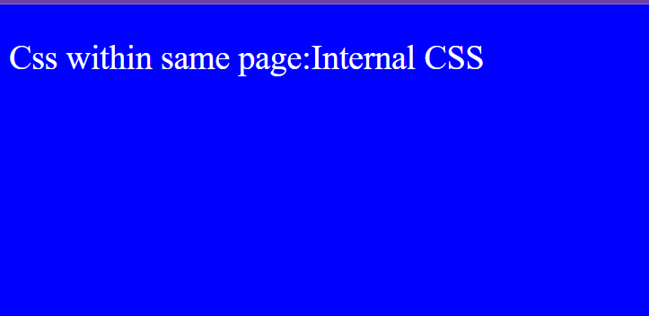

**Linking with an external page:**

The <link> tag refers to an external CSS file.

* rel: Specifies the relationship, here it's "stylesheet".
* type: Specifies the type, which is "text/css".
* href: Specifies the name of the CSS file.

External page css code:

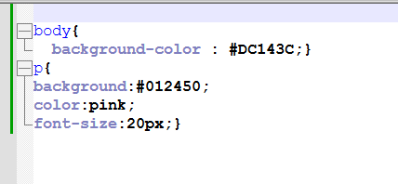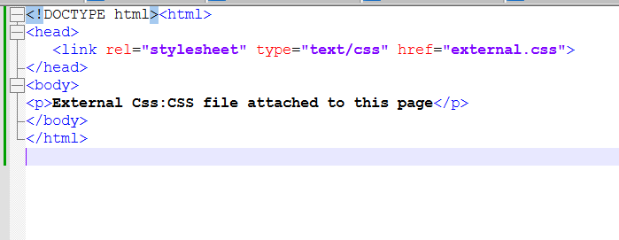

Output:

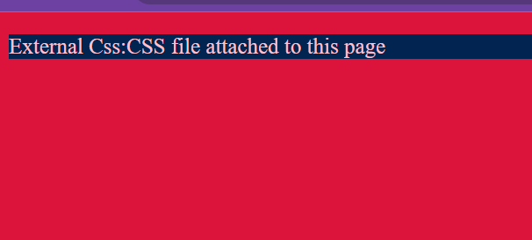

Display images and gifs code:

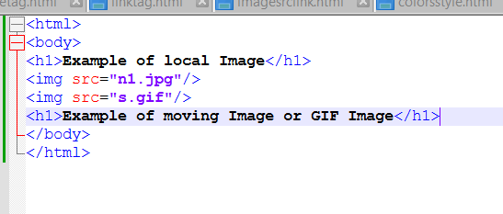

Output:

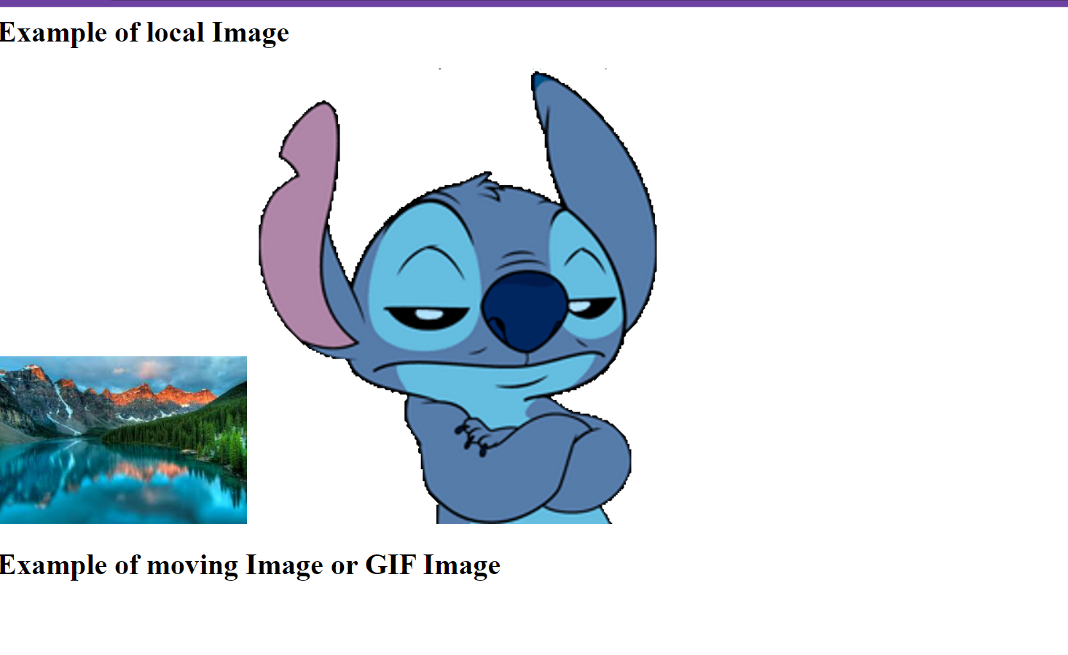

Image maps:

An image map divides an image into multiple hyperlinks using coordinates specified in the coords attribute. Coordinates define a rectangle from the top-left to the bottom-right. When clicked, the associated HTML file is executed.

Image maps code:

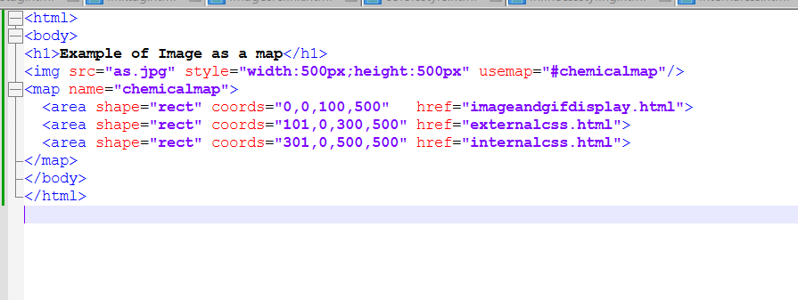

Output:

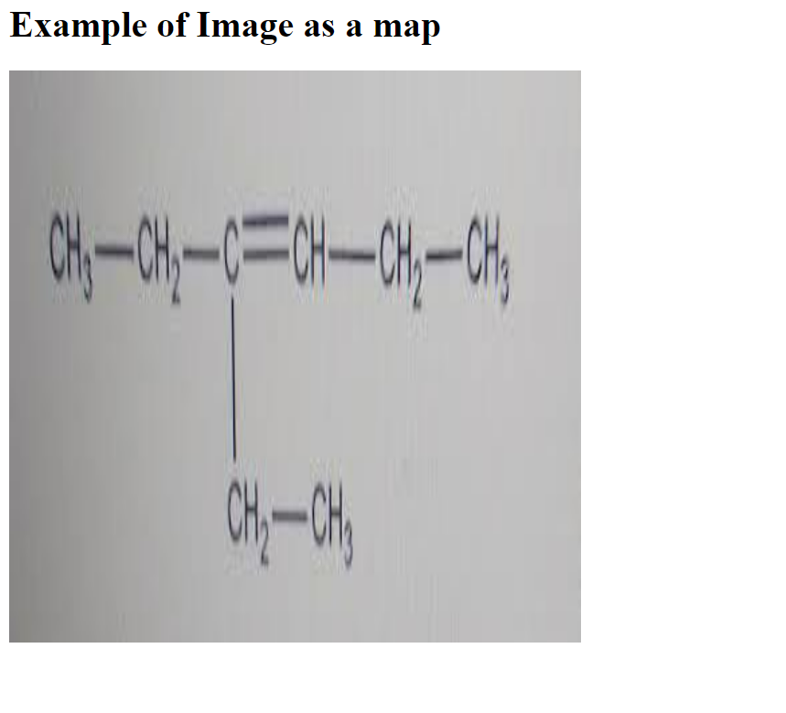

**Block:**

Many elements can be placed in one block using Div tag. Style for the entire block can be specified using style attribute in the div tag.

Block div tag code:

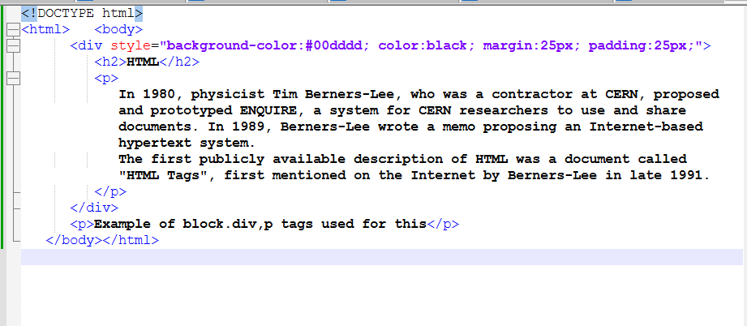

Output:

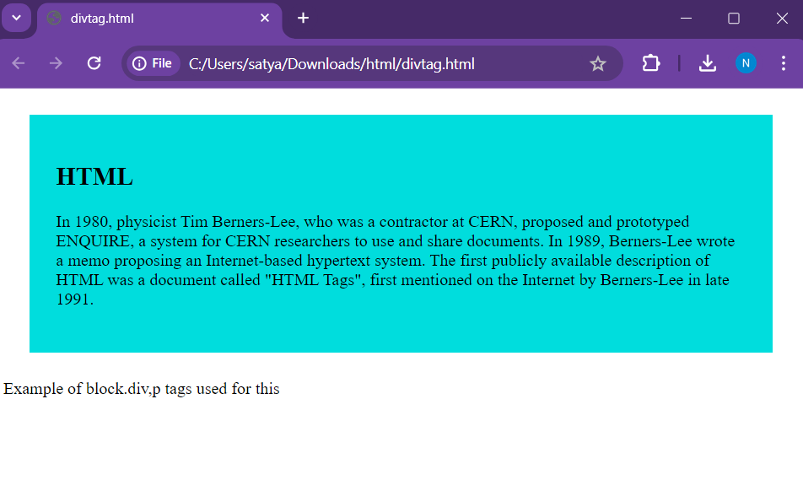

In the code, background-color, color, margin, and padding are set for the div element, which contains a header. The span tag styles part of the text within headers or paragraphs.

Div element example code:

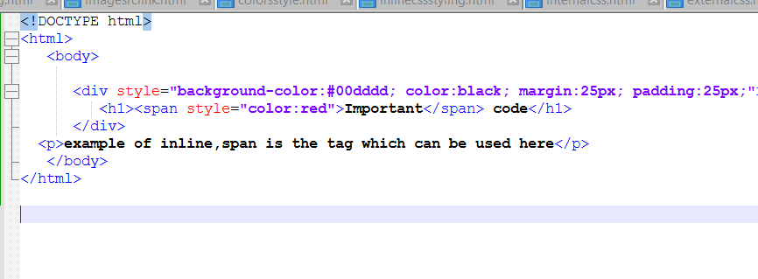

Output:

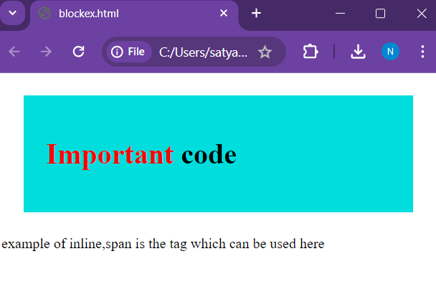

Tables:

The <table> tag creates a table in HTML.

* <tr> defines a table row.
* <td> specifies table data; use three <td> tags for three columns.
* <th> specifies a table header.
* <row span=n> merges n rows.
* <col span=n> merges n columns.

The style attribute can style table elements (tr, td, th). For example, width="50%" sets the table to 50% of the window's width, and border="1px" sets a 1px border

Table code:



Output:

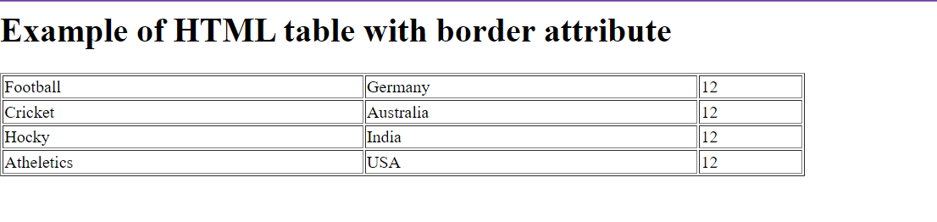

Table with header styles:

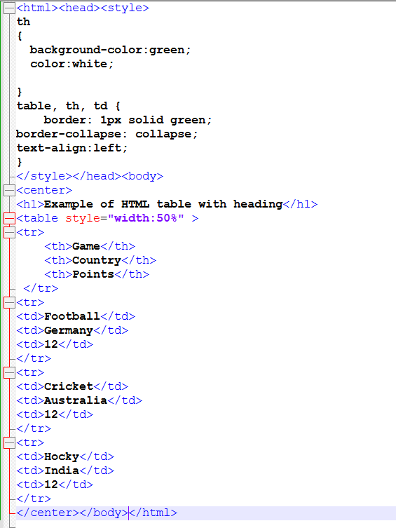

Output:

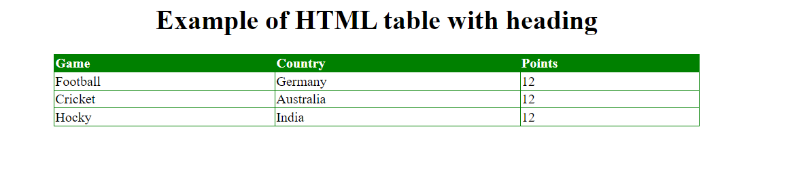

Row span in table:

* table tr:nth-child(even) styles even rows.
* table tr:nth-child(odd) styles odd rows.
* rowspan="2" merges two rows.
* The <caption> tag adds a centered caption at the top of the table

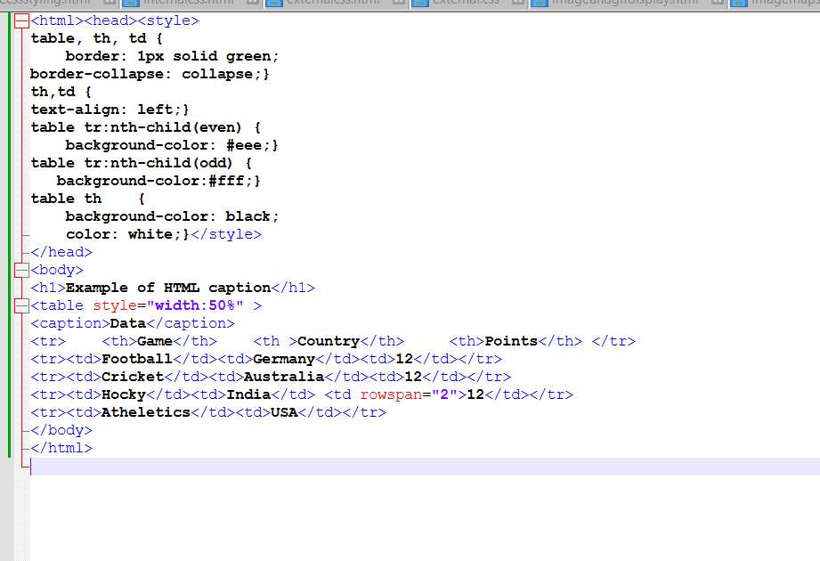

Output:

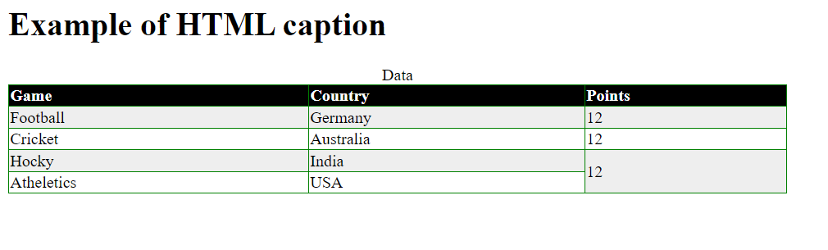

**Lists:**

* Ordered lists (<ol>) display items with ordered indices (1, 2, 3 or A, B, C or i, ii, iii).
* Unordered lists (<ul>) display items with symbols (disc, circle, square, none).
* List items are specified with <li> tags.
* list-style-type for unordered lists can be disc, circle, square, or none.
* type for ordered lists can be 1, A, a, I, or i.

Unordered list:

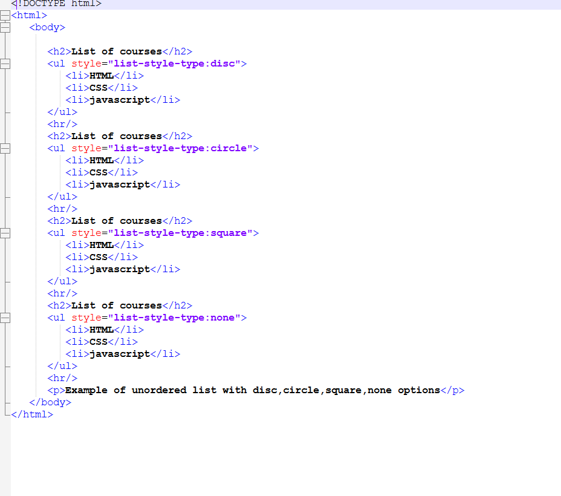

Output:

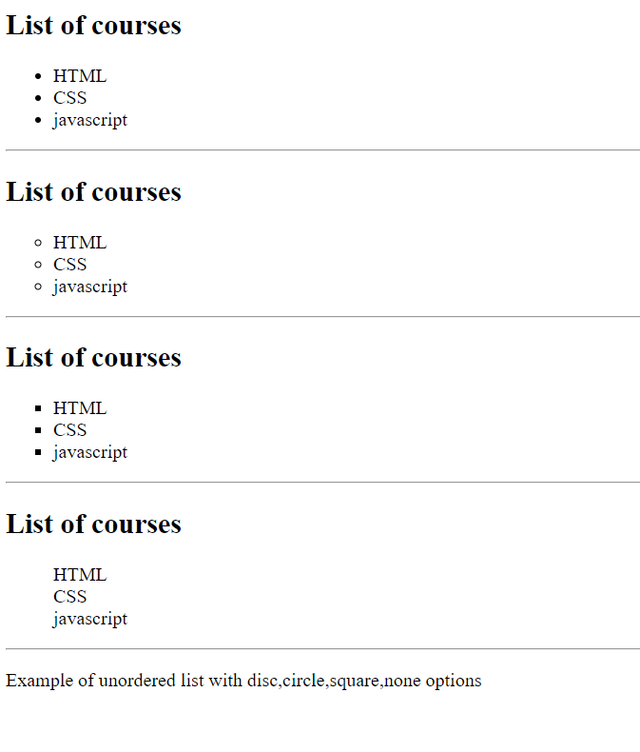

Ordered lists code:

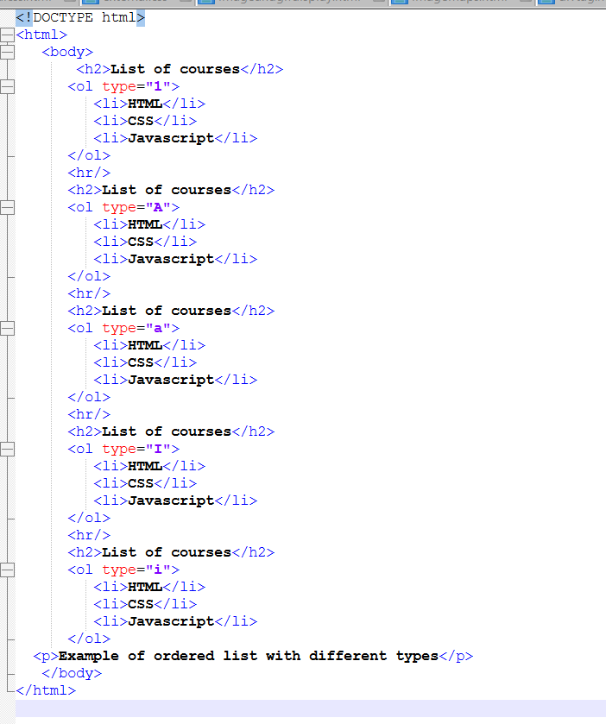

Output:

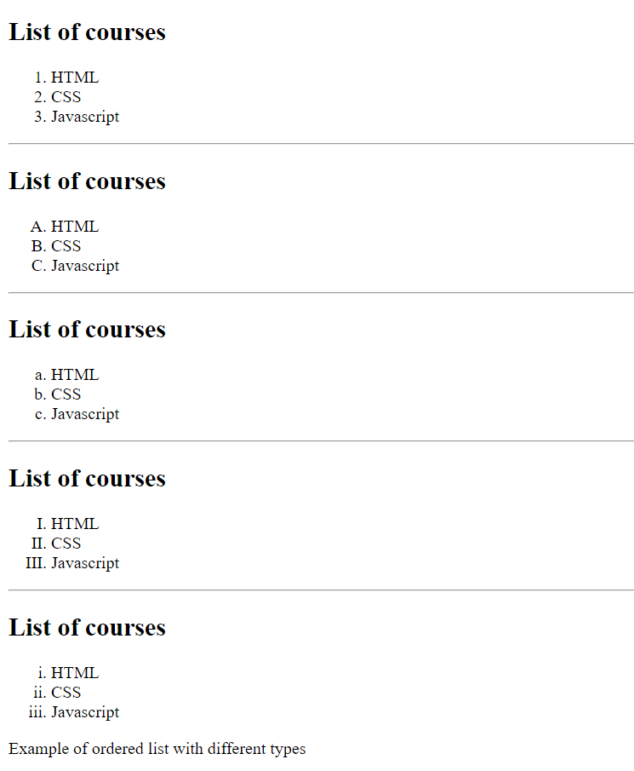

**Layout:**

A website can be divided into multiple sections using <div> tags:

* Header
* Left menu (anchors)
* Main content
* Footer

Styles for each section are specified using the <style> tag

Layout code:

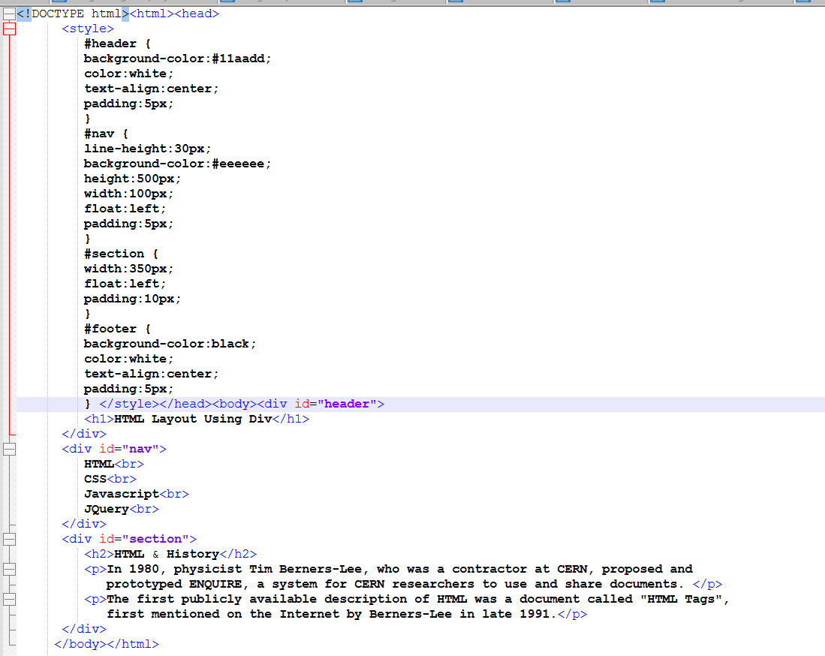

Output:

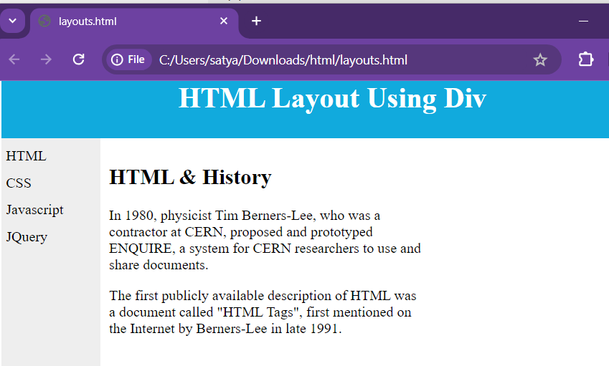

**Forms:**

Forms send data to the server using the <form> tag.

Form elements include:

* Radio buttons
* Checkboxes
* Text areas
* Buttons
* Drop-down boxes
* List boxes

The <input> tag is used for input elements, with the type attribute specifying the input type:

* text: Text boxes
* button: Push buttons
* radio: Radio buttons
* checkbox: Checkboxes
* submit: Submit button (sends data to the server)

Textbox example code:

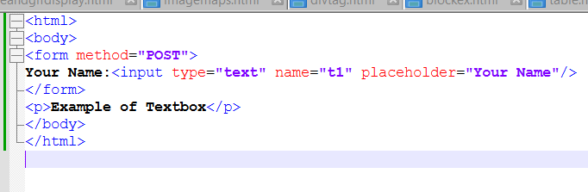

Output:

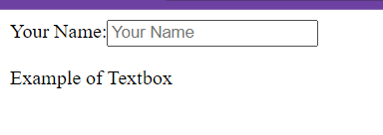

Password example code:

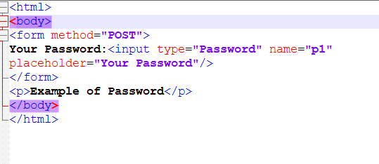

Output:

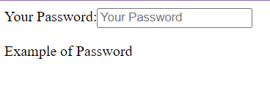

Radio button code:

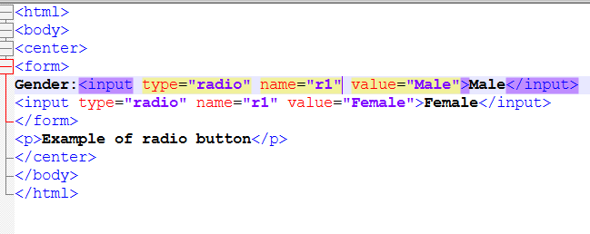

Output:

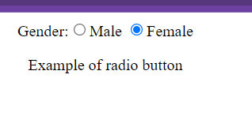

Checkbox code:

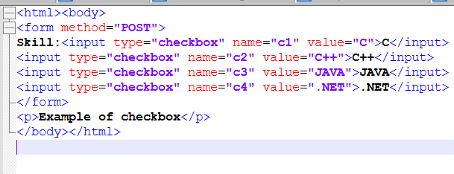

Output:

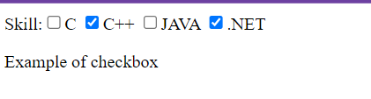

**Dropdown list in forms code:**

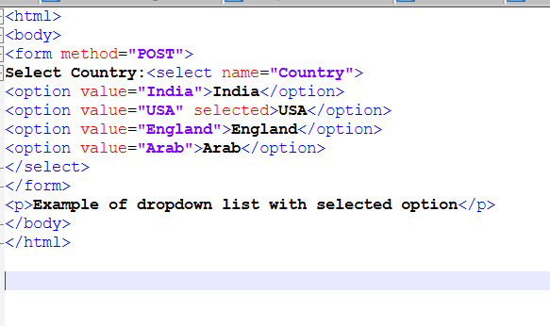

**Output:**

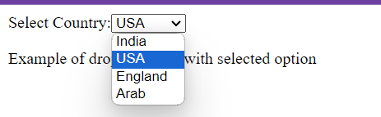

**Form complete example code:**

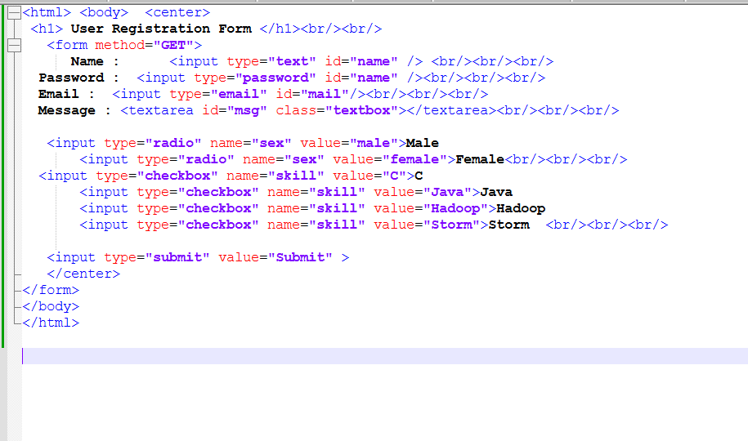

**Output:**

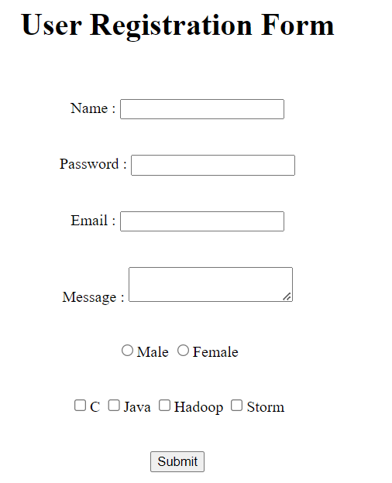

**Iframes:**

Iframes are used to display a website or web page within another web page.

An <iframe> tag with a specific name can display new content when a hyperlink is clicked. For example, a hyperlink with JavaScript triggers the iframe to load a new HTML page.

Example code:

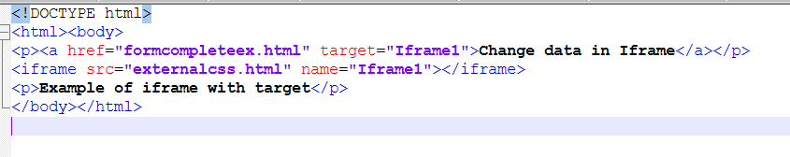

Output:

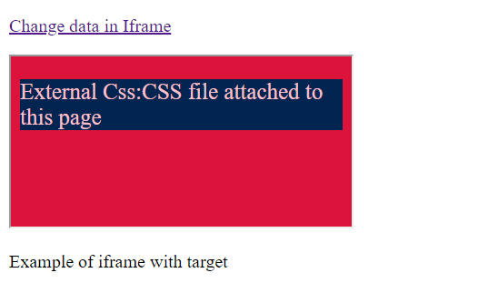

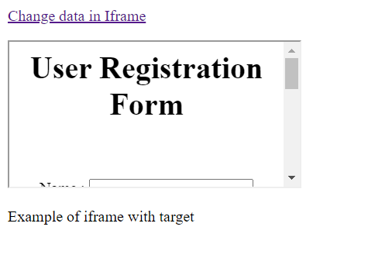

Entities:

HTML entities are special characters represented by specific codes. Here are some common HTML entities:

* &nbsp; - Non-breaking space.
* &lt; - < (less than sign).
* &gt; - > (greater than sign).
* &amp; - & (ampersand).
* &pound; - £ (pound symbol).
* &yen; - ¥ (yen symbol).
* &euro; - € (euro symbol).
* &copy; - © (copyright symbol).

Entities code:

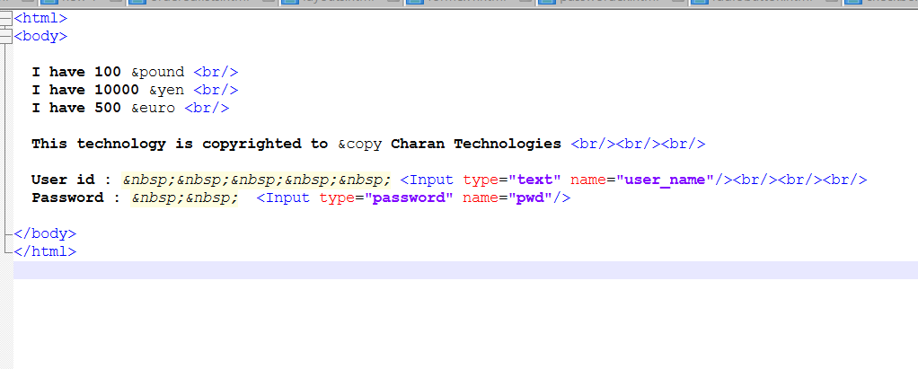

Output:

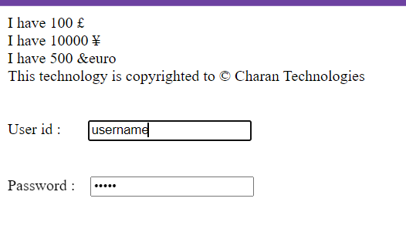

**Symbols:**

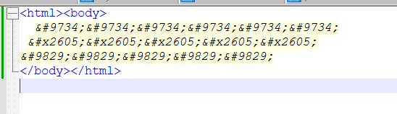

**Output:**

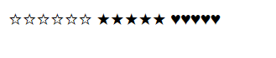

Some Mathematical Symbols Supported by HTML

Char Number Entity Description

∀ &#8704; &forall; FOR ALL

∂ &#8706; &part; PARTIAL DIFFERENTIAL

∃ &#8707; &exist; THERE EXISTS

∅ &#8709; &empty; EMPTY SETS

∇ &#8711; &nabla; NABLA

∈ &#8712; &isin; ELEMENT OF

∉ &#8713; &notin; NOT AN ELEMENT OF

∋ &#8715; &ni; CONTAINS AS MEMBER

∏ &#8719; &prod; N-ARY PRODUCT

∑ &#8721; &sum; N-ARY SUMMATION

Some Other Entities Supported by HTML

Char Number Entity Description

© &#169; &copy; COPYRIGHT SIGN

® &#174; &reg; REGISTERED SIGN

€ &#8364; &euro; EURO SIGN

™ &#8482; &trade; TRADEMARK

← &#8592; &larr; LEFTWARDS ARROW

↑ &#8593; &uarr; UPWARDS ARROW

→ &#8594; &rarr; RIGHTWARDS ARROW

↓ &#8595; &darr; DOWNWARDS ARROW

♠ &#9824; &spades; BLACK SPADE SUIT

♣ &#9827; &clubs; BLACK CLUB SUIT

♥ &#9829; &hearts; BLACK HEART SUIT

♦ &#9830; &diams; BLACK DIAMOND SUIT

Code:

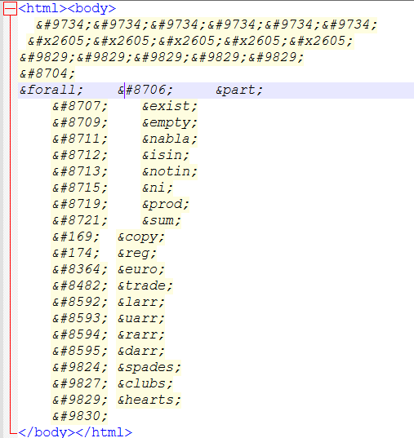

Output:



**Character set:**

* ASCII Charset: Contains characters from A-Z, 0-9, and some symbols.
* ANSI (256 characters): A standard encoding for various characters and symbols.
* ISO-8859-1 (256 characters): The default character set in HTML4.
* UTF-8: Supports almost all characters and symbols worldwide.

**<meta charset="UTF-8">**

**Code:**

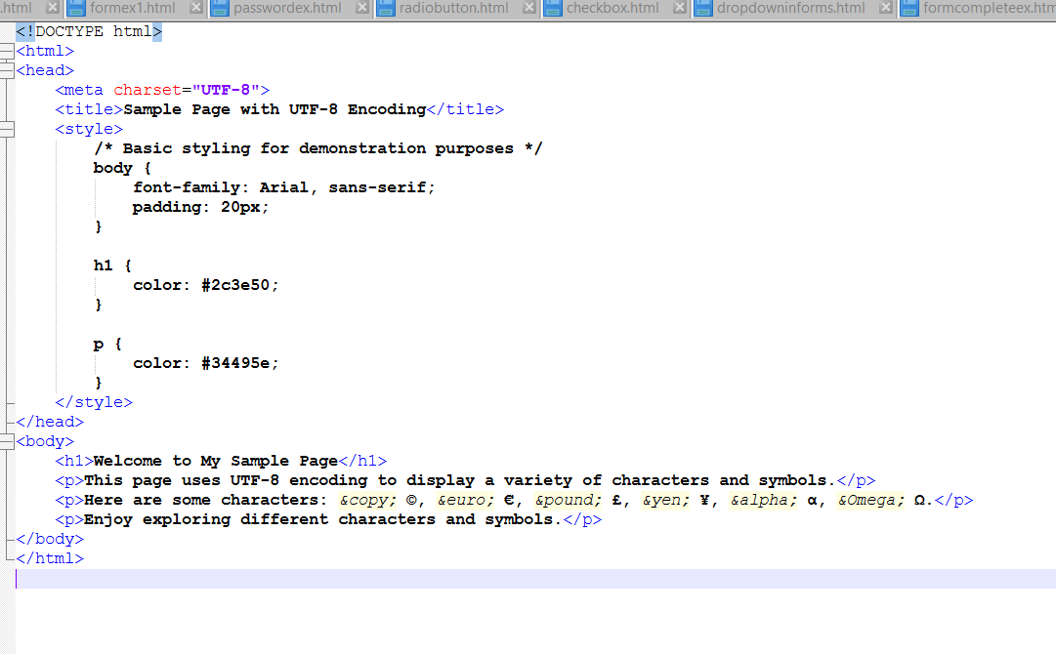

**Output:**

